Aim:Evaluation of Infix, Prefix and Postfix expression

CODE:
//Infix to Postfix Ayush 1NT21IS041
#include<stdio.h>
#include<stdlib.h> // Header declaration
int stack[20]; //declaring Stack globally
int top=-1; //declaring top=-1

void push(char x) //push function to insert
{
stack[++top]=x; //pushing items into stack
}

char pop() //pop function to take out
{a
if (top==-1) //checking if stack is empty
{
return 1;
}
else
{
return stack[top--];
}
}

int priority(char x) //priority function to give order of preference
{
if(x=='(') //checking stack items
{
return 0; //if stack item is "(" then returns 0
}
if(x=='+'||x=='-')
{
return 1; //if stack item is "+" or "-" then returns 1
}
if(x=='*'||x=='/')
{
return 2; //if stack item is "*" or "/" then returns 2
}

}

int main() //Main function
{
char exp[20]; //declaring character array
char *e,x;
printf("Enter the exp \n");
scanf("%s", exp); //Taking in expression
e=exp;
while(*e!='\0') //while the pointer is'nt 0 execute the given set of statements
{
if(isalnum(*e)) //checking if pointer is alphanumeric
{
printf("%c" , *e);
}
else if(*e=='(') //checking if pointer is "("
{
push(*e); //push into the stack
}
else if(*e==')') //checking if pointer is ")"
{
while((x = pop())!='(') //while loop for pop
{
printf("%c",x);
}
}
else
{
while(priority(stack[top])>=priority(*e)) // priority checking

printf("%c", pop());
push(*e);
}
e++;
}
while(top!=-1) //if stack is not empty pop
{
printf("%c",pop());
}
return 0;
printf("\n");

}

OUTPUT:
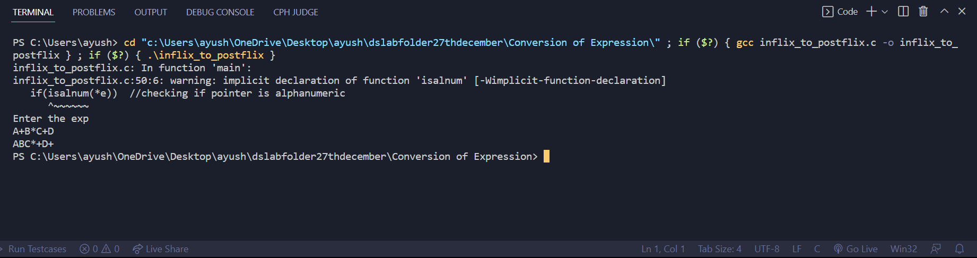

Postflix to Prefix:

#include<stdio.h>
#include<string.h>
#include<stdlib.h>
#define MAX 20

char str[MAX], stack[MAX];
int top=-1;

void push(char c)
{
stack[++top]=c;
}

char pop()
{
return stack[top--];
}

int checkifoperand(char ch)
{
return (ch>='a'&&ch<='z')||(ch>='A'&&ch<='Z');
}

int isoperator(char x)
{
switch(x)
{
case '+':
case '-':
case '/':
case '*':
return 1;
}
return 0;
}

void postfixtoprefix()
{
int n,i,j=0;
char c[20];
char a,b,op;
printf("Enter the postfix expression\n");
scanf("%s" , str);
n=strlen(str);
printf("Prefix expression is : \t");
for(i=0;i<MAX;i++)
{
stack[i]='\0';

}
for(i=n-1; i>=0; i--)
{
if(isoperator(str[i]))
{
push(str[i]);
}
else
{
c[j++]=str[i];
while((top!=-1)&&(stack[top]=='#'))
{
a=pop();
c[j++]=pop();
}
push('#');
}
}
c[j]='\0';
i=0;
j=strlen(c)-1;
char d[20];
while(c[i]!='\0')
{
d[j--]=c[i++];
}
printf("%s\n", d);
}

int main()
{
postfixtoprefix();
return 0;
}

OUTPUT:
